  - The Wellness Wheel
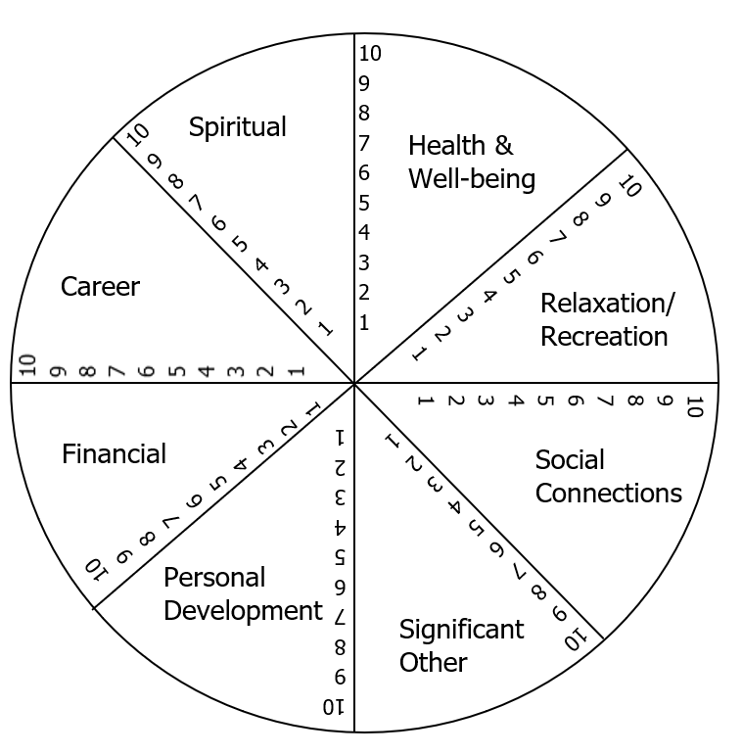
Rank your satisfaction in each of the areas below from 0 (dissatisfied) to 10 (satisfied), then connect the dots to find your personalized circle.

Note the areas that you are satisfied with: ______________________________________________________________
______________________________________________________________
Note the areas you would like to work on changing in the near future:
______________________________________________________________
______________________________________________________________
Northwoods Health & Wellness Coaching, LLC
Paula Sweney-Wagler CHWC, RD
ArtStart ∙ 68 S. Stevens St. Rm B9 ∙ Rhinelander, WI.
P.O. Box 1315
Phone: 715-367-4609
Northwoods Health & Wellness Coaching contact@northwoodshealthwellnesscoaching.com

