IMPROVE YOUR ENERGY

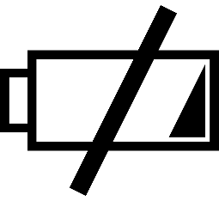
What drains your energy?
- Poor or insufficient sleep
- Too little physical activity
- Stress
- Negative thoughts or feelings
- Work issues
- Family or relationship issues
- Financial issues
- Physical health issues
Other ____________________________________________________________

What improves your energy?
- Healthy sleep
- Regular physical activity
- Healthy eating habits
- Stress management, relaxation, or fun activities
- Healthy mindset
- Healthy family/personal relationships
- Job satisfaction
- Spiritual activities
- Healthy finances
Other ____________________________________________________________

List one small activity that you can do this week to help you feel more energized. How will you remember to do this - ex: schedule it on your calendar, post a sticky note reminder, set a phone alarm, enlist a friend to support you? How will your life be improved – better quality of family time, productivity, relaxation, mood, relationships?
______________________________________________________________________________
______________________________________________________________________________
______________________________________________________________________________

