|  |
| --- |
| ***MINDFUL EATING***  It’s easy for us to recognize when we are overly hungry or uncomfortably full. If we can begin to notice the subtle cues in-between these two extremes, we are more likely to have a better eating experience. Using the hunger scale, try eating more often when your hunger is at a 3 or 4 to help you avoid overeating. Before you choose to eat, try asking yourself, “Am I hungry?” If you are bored, stressed, or sad, can you do something else to meet your needs instead of eating? You can still choose to eat if you’re not hungry, but with practice, you may begin to choose other activities to meet your needs instead of food.  To prepare to eat mindfully, turn off all devices and distractions and just eat without doing anything else. Take a deep breath, and use all your senses to appreciate your food. Notice the appearance and the aroma, then take a bite, and put your fork down. You can close your eyes if you wish, and focus on the taste and the texture of your food as you chew slowly.  You can also divide the food on your plate in half, then put your fork down for a few minutes when you reach the half-way point. Is your hunger gone, do you need a few more bites, or are you still hungry enough to clean your plate? Sometimes you will choose to continue to eat because the food tastes so good, and that’s ok! But as you begin to pay more attention to the amount of food your body needs to satisfy you; you may find that you are satisfied with less.  Don’t judge yourself if it’s initially difficult to eat mindfully, just do your best and remember that new habits take time! |

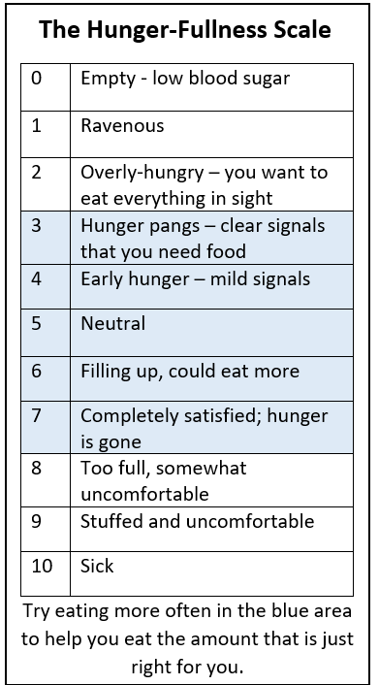

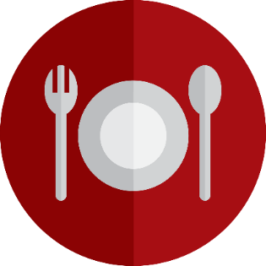

Paula Sweney-Wagler CHWC, RD, CD

Northwoods Health & Wellness Coaching, LLC

P.O. Box 1315

ArtStart ∙68 S. Stevens St. Rm B9 ∙ Rhinelander, WI. 54501

Phone: 715-367-4609

www.northwoodshealthwellnesscoaching.com

[Northwoods Health & Wellness Coaching](https://www.northwoodshealthwellnesscoaching.com/) contact@northwoodshealthwellnesscoaching.com